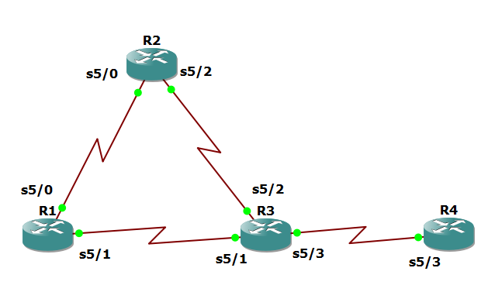

Router R1

config

hostname R1

!

interface Lo1

description R1 LAN

ip address 192.168.1.1 255.255.255.0

!

interface Serial5/0

description R1 --> R2

ip address 172.16.12.1 255.255.255.248

clock rate 128000

bandwidth 128

no shutdown

!

interface Serial5/1

description R1 --> R3

ip address 172.16.13.1 255.255.255.248

bandwidth 64

no shutdown

!

end

Router R2

config

hostname R2

!

interface Lo2

description R2 LAN

ip address 192.168.2.1 255.255.255.0

!

interface Serial5/0

description R2 --> R1

ip address 172.16.12.2 255.255.255.248

bandwidth 128

no shutdown

interface Serial5/2

description R2 --> R3

ip address 172.16.23.2 255.255.255.248

clock rate 128000

bandwidth 128

no shutdown

!

end

Router R3

config

hostname R3

!

interface Lo3

description R3 LAN

ip address 192.168.3.1 255.255.255.0

!

interface Serial5/1

description R3 --> R1

ip address 172.16.13.3 255.255.255.248

clock rate 64000

bandwidth 64

no shutdown

!

interface Serial5/2

description R3 --> R2

ip address 172.16.23.3 255.255.255.248

bandwidth 128

no shutdown

!

interface Serial5/3

description R3 --> R4

ip address 172.16.34.3 255.255.255.248

clock rate 64000

bandwidth 64

no shutdown

!

end

Router R4

config

hostname R4

!

interface Lo4

description R4 LAN A

ip address 192.168.4.1 255.255.255.128

!

interface Lo5

description R4 LAN B

ip address 192.168.4.129 255.255.255.128

!

interface Serial5/3

description R4 --> R3

ip address 172.16.34.4 255.255.255.248

bandwidth 64

no shutdown

!

end

R3# show ip interface brief | include up

show protocols

show interfaces description | include up

Router R1

config

router eigrp 1

network 192.168.1.0

network 172.16.12.0 0.0.0.7

network 172.16.13.0 0.0.0.7

no auto-summary

Router R2

config

router eigrp 1

network 192.168.2.0

network 172.16.12.0 0.0.0.7

network 172.16.23.0 0.0.0.7

no auto-summary

Router R3

config

router eigrp 1

network 192.168.3.0

network 172.16.13.0 0.0.0.7

network 172.16.23.0 0.0.0.7

network 172.16.34.0 0.0.0.7

no auto-summary

Router R4

config

router eigrp 1

network 192.168.4.0

network 172.16.34.0 0.0.0.7

no auto-summary

R1# show ip eigrp neighbors

R2# show ip eigrp neighbors

R3# show ip eigrp neighbors

R4# show ip eigrp neighbors

R1# tclsh

foreach address {

172.16.12.1

172.16.12.2

172.16.13.1

172.16.13.3

172.16.23.2

172.16.23.3

172.16.34.3

172.16.34.4

192.168.1.1

192.168.2.1

192.168.3.1

192.168.4.1

192.168.4.129

} { ping $address }

R1# show ip route | begin Gateway

R4# traceroute 192.168.1.1 source 192.168.4.1

R4# traceroute 192.168.1.1 source 192.168.4.129

R3# show ip route | begin Gateway

R3# show interfaces serial5/1

R3# show interfaces serial5/1 | include BW

R3# show interfaces serial5/2 | include BW

R3# show ip eigrp topology 192.168.1.0

R3(config)# ip access-list standard PBR-ACL

remark ACL matches R4 LAN B traffic

permit 192.168.4.128 0.0.0.127

exit

R3(config)# route-map R3-to-R1 permit

description RM to forward LAN B

match ip address PBR-ACL

set ip next-hop 172.16.13.1

exit

R3(config)# interface s5/3

ip policy route-map R3-to-R1

end

R3# show route-map

R3# conf t

R3(config)# access-list 1 permit 192.168.4.0 0.0.0.255

exit

R3# debug ip policy ?

R3# debug ip policy 1

R4# traceroute 192.168.1.1 source 192.168.4.1

R4# traceroute 192.168.1.1 source 192.168.4.129

R3# show route-map